### **9. Switch Interfaces**

### **Cisco CLI for Switches**

#### **Entering Privileged EXEC Mode**

Enter Privileged EXEC mode:  
 SW1> enable

Show all interfaces and their statuses:  
 SW# show ip interface brief

* + Displays Interface, IP Address, Method, Status (Layer 1), and Protocol (Layer 2).
  + **Switches Default Behavior:** Interfaces are **not administratively down**, unlike routers (shutdown command). Unused ports show as "down/down."

### **Show Interface Status**

Command:

SW1# show interfaces status

Displays:

* **Port:** Interface name.
* **Name:** Description.
* **Status:** Connection status (connected, notconnect).
* **VLAN:** VLAN assigned to the interface (default is VLAN 1).
* **Duplex:** Full or half (default: Auto).
* **Speed:** Mbps (default: Auto).
* **Type:** Medium type and interface capability.

### **Configuring a Range of Interfaces**

To save time configuring multiple interfaces:

Enter Global Config Mode:  
 SW1# conf t

Select an Interface Range:  
 SW1(config)# interface range f0/5 - 12 or int range f0/5 - 6, f0/9 -12 works too

Apply Configurations (e.g., Add Description, Shutdown Unused Ports):  
SW1(config-if-range)# description ## not in use ##

SW1(config-if-range)# shutdown

Verify Status:  
 SW1# show interfaces status



Set speed:

SW1(config-if-range)# speed 1000

Set Duplex:

SW1(config-if-range)# duplex full/half

### **Full Duplex vs Half Duplex**

* **Full Duplex:** Devices can send and receive simultaneously. Supported by most modern switches.
* **Half Duplex:** Devices can either send or receive, not both. Rarely used today but was common in LAN hubs.

#### **Collisions and CSMA/CD**

* **Half Duplex Devices** use **CSMA/CD (Carrier Sense Multiple Access with Collision Detection):**
  + Devices "listen" to the collision domain before sending data.
  + If a collision occurs, a jamming signal is sent, and devices retry after a random delay.
  + Collisions occur in **collision domains** (e.g., devices connected to a hub).
* **Switches (Layer 2):** Minimize collisions by providing dedicated connections.Devices attached to a switch can operate in a full duplex.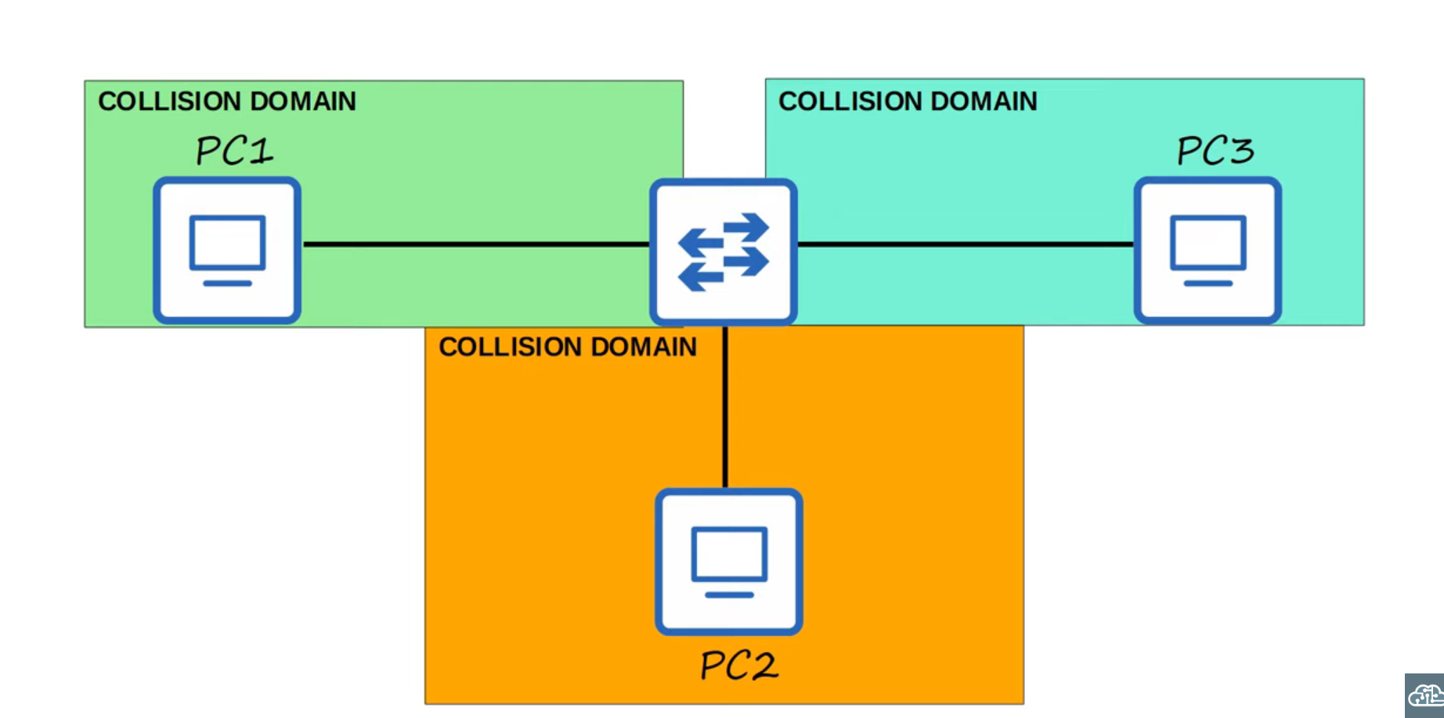
* **Hubs (Layer 1):** Flood frames, leading to frequent collisions.Devices attached to a hub must operate in half duplex.

### **Speed and Duplex Auto-Negotiation**

Switches default to **auto-negotiation** for speed and duplex settings:

1. Interfaces advertise their capabilities.
2. They negotiate the best speed and duplex settings.

#### **If Auto-Negotiation Fails:**

* **Speed:**
  + The switch attempts to match the device’s speed.
  + If unsupported, it defaults to the **lowest speed (e.g., 10 Mbps)**.
* **Duplex:**
  + For 10/100 Mbps: Defaults to **Half Duplex**.
  + For 1000 Mbps or higher: Defaults to **Full Duplex**.

### **Interface Counters and Error Types**

To check interface statistics and errors:

SW1# show interfaces <interface name>

Displays the following error stats:

1. **Runts:** Frames smaller than 64 bytes.
2. **Giants:** Frames larger than 1518 bytes.
3. **CRC Errors:** Frames failing the Cyclic Redundancy Check (CRC).
4. **Frame Errors:** Frames with incorrect format.
5. **Input Errors:** Total of all receive errors (e.g., runts, giants, CRC).
6. **Output Errors:** Frames the switch attempted to send but failed.

### **Key Takeaways**

* Switches are **Layer 2** devices, reducing collisions with dedicated connections.
* Auto-negotiation simplifies speed and duplex setup but may need manual tuning if disabled.
* Use interface range to efficiently manage multiple ports.
* Monitor **interface errors** to diagnose connection issues effectively.